Unit 4: Algebraic Expressions and Equations
Answer Key
Skill #1 Use Order of Operations
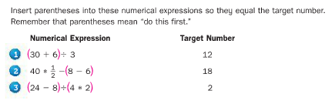
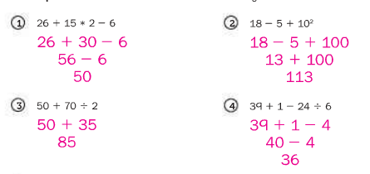
Skill #2 Write an algebraic expression to represent a situation or to generalize a pattern.
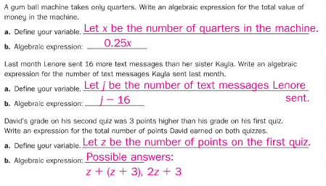

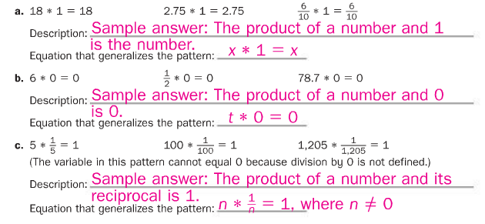
Skill #3 Write equivalent expressions using properties
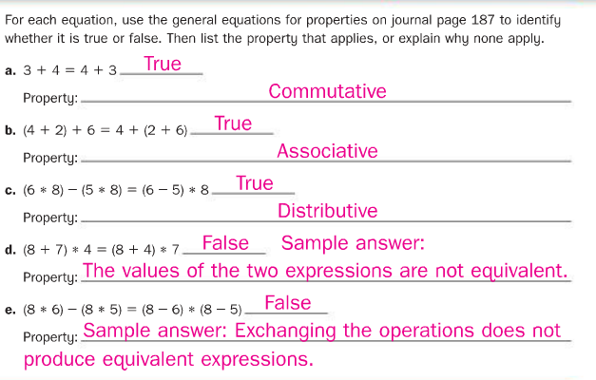

Skill #4 Write and solve simple equations with one variable
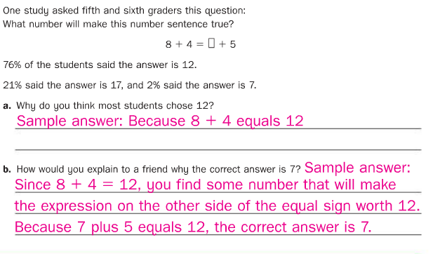
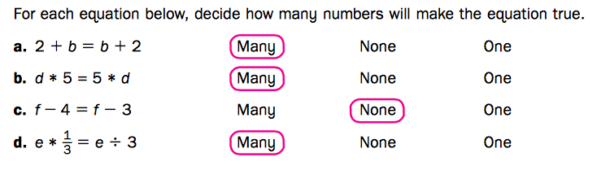

Skill #5 Recognize and use the Distributive Property
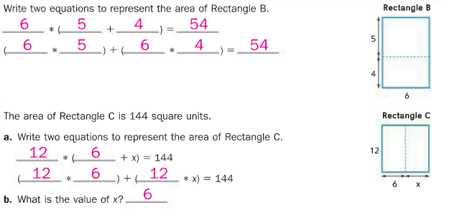
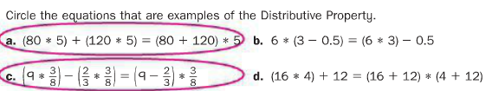
Skill #6
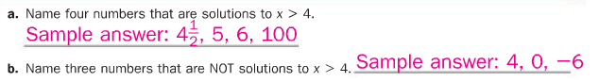
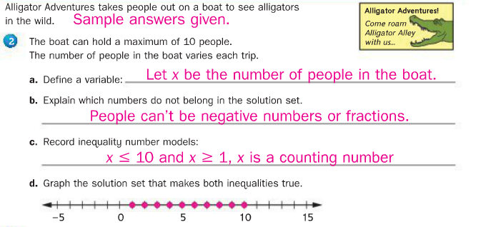
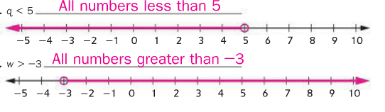
Skill #7 Solve absolute value problems
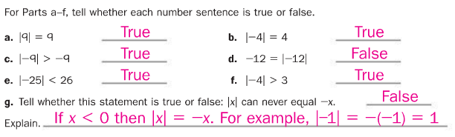
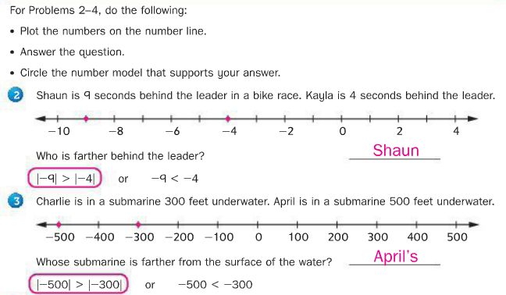

Skill # 8 Find the interquartile range and mean absolute deviation for a data set.
